Asimov on Astronomy, Doubleday 1974 First Edition, First Print. No gutter code. As new unclipped dust jacket price $8.95 art by David November. As new hardcover with all 238 pages tightly bound and no marks of any kind. 8vo ISBN 038504111X
Asimov’s collection of essays on astronomy, reflecting his deep understanding of a scientific view of the universe.

ID 000357 Price $55 Box 7

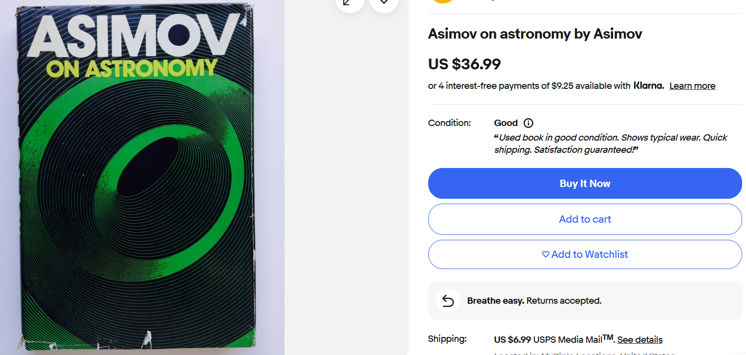
AbeBooks
Sterling Vintage Books $49

